Name : Durgesh Amol Gaikwad
Class: fy-cy
Collage : Sanjivani university
Subject : NPC

Unit 1: Introduction to Networking and Data
Communication
Mini-Project: Building a LAN in Cisco Packet Tracer (Free Tier)
Task Outline: Download and install the free Cisco Packet Tracer (via Cisco Networking
Academy). Build a Local Area Network consisting of 1 Router, 2 Switches, and 4 PCs.
Assign static IP addresses to all PCs. Demonstrate successful communication by pinging
across the switches. Take a screenshot of the topology and the successful ping responses.

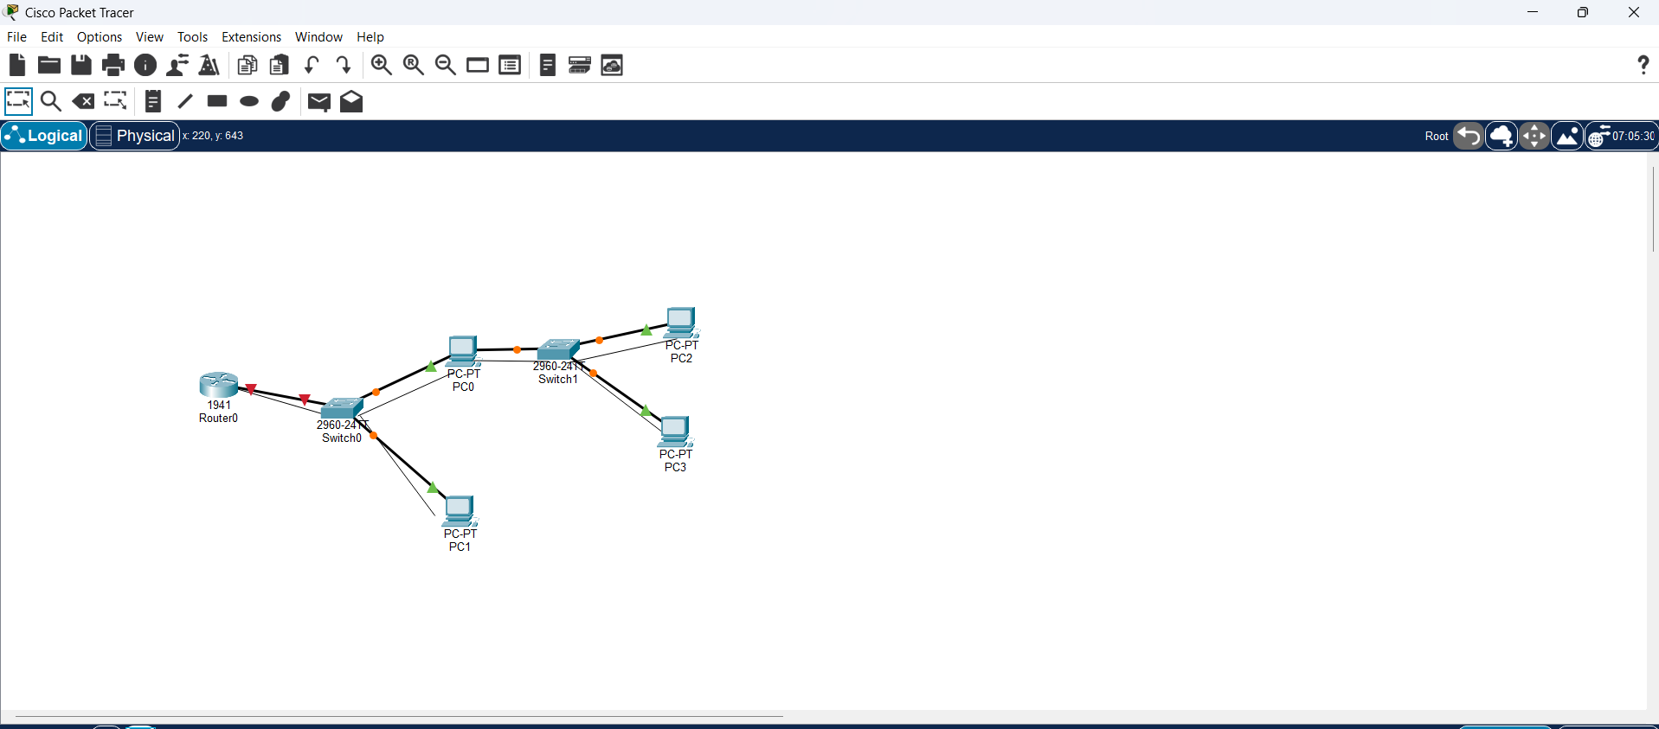

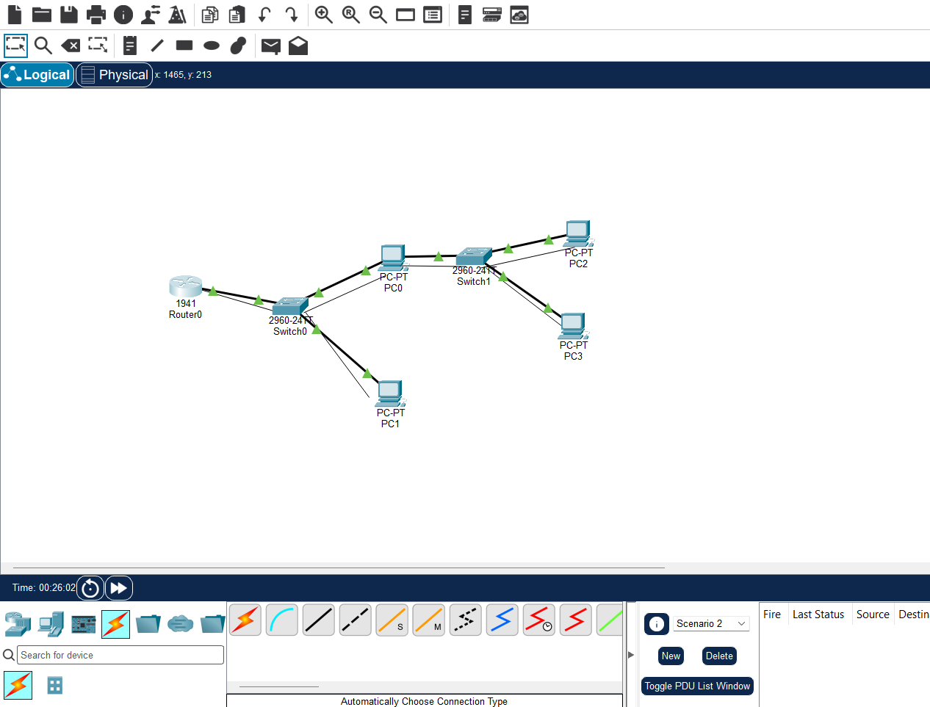

- Command Lines :
enable
configure terminal
interface gigabitEthernet 0/0
ip address 192.168.1.1 255.255.255.0
no shutdown
exit
exit

- PING:

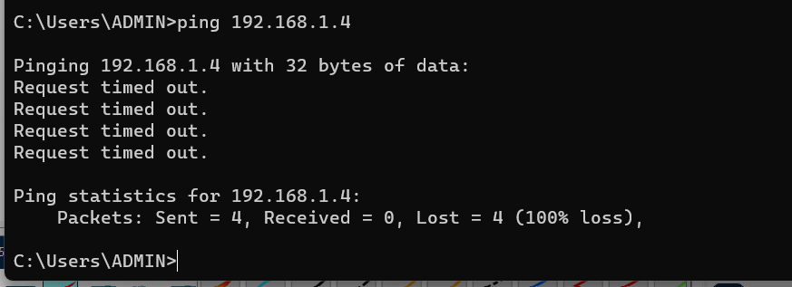

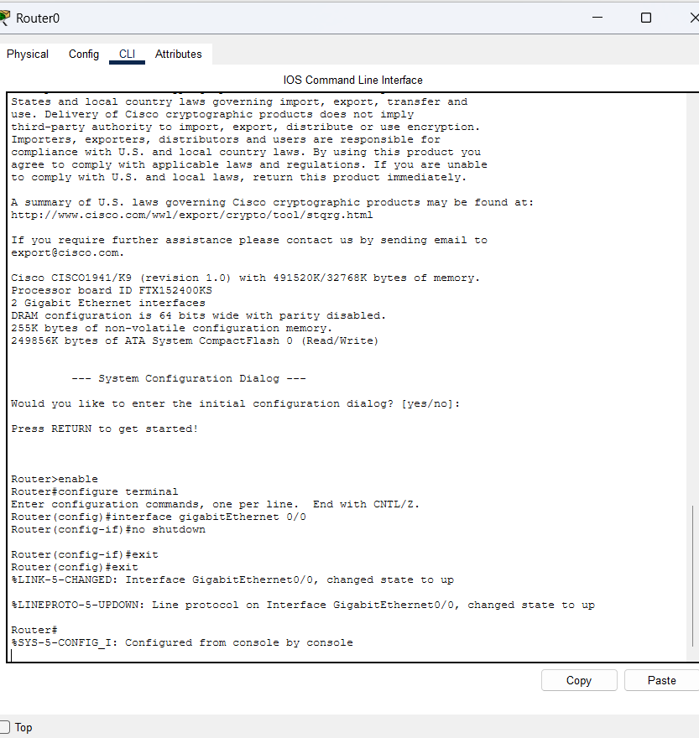
- TOPOLOGY :

